I Mô hình khái niệm

Sơ đồ thực thể - quan hệ

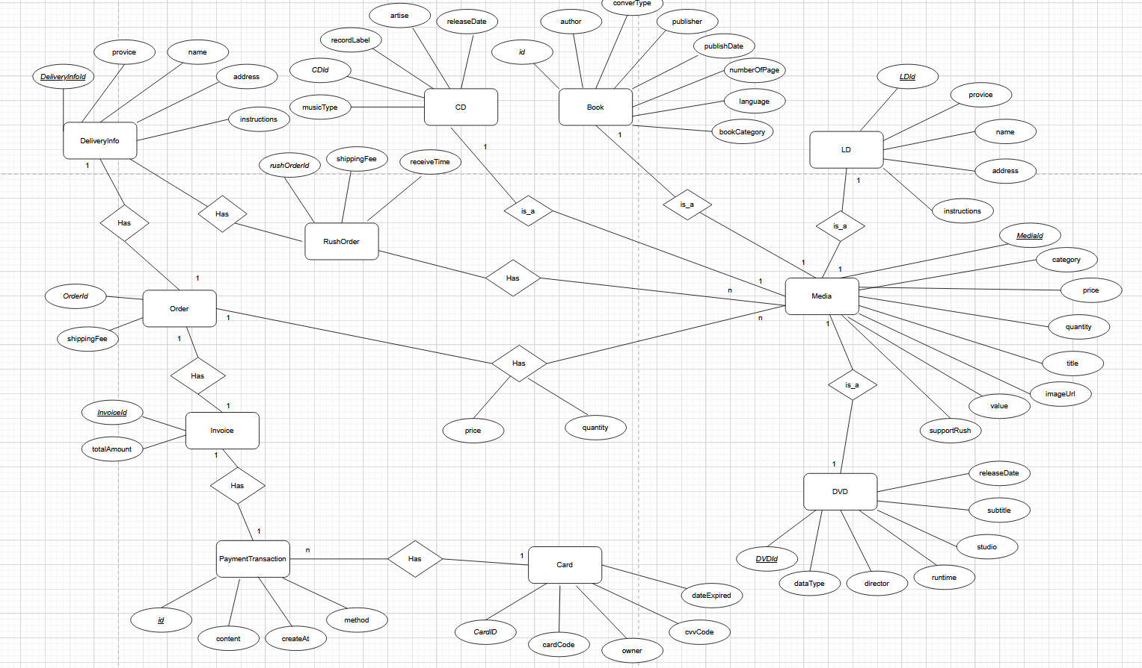

II Mô hình dữ liệu logic

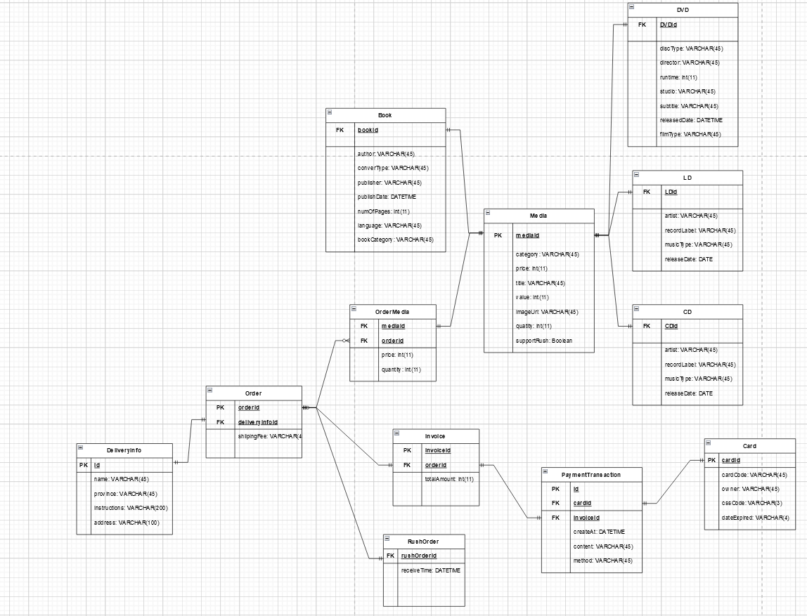

III Mô hình dữ liệu vật lý

Chú thích:

PK: Primary Key

FK: Foreign Key

1 Media

|  |  |  |  |  |  |  |
| --- | --- | --- | --- | --- | --- | --- |
| **STT** | **PK** | **FK** | **Column Name** | **Data type** | **Mandatory** | **Description** |
| 1 | x |  | mediaId | Integer | Yes | ID, autoincrement |
| 2 |  |  | category | VARCHAR(45) | Yes | Media type, e.g: CD, DVD |
| 3 |  |  | price | Integer | Yes | Current price |
| 4 |  |  | title | VARCHAR(45) | Yes | Product name |
| 5 |  |  | value | Integer | Yes | Value of the product |
| 6 |  |  | imageUrl | VARCHAR(45) | Yes | Product image path |
| 7 |  |  | quantity | Integer | Yes | Number of product |
| 8 |  |  | supportRush | Boolean | Yes | Check this product support rush order |

2 CD

|  |  |  |  |  |  |  |
| --- | --- | --- | --- | --- | --- | --- |
| **STT** | **PK** | **FK** | **Column Name** | **Data type** | **Mandatory** | **Description** |
| 1 |  | x | CDId | Integer | Yes | ID, not null, auto increment |
| 2 |  |  | artist | VARCHAR(45) | Yes | Artist’s name |
| 3 |  |  | recordLabel | VARCHAR(45) | Yes | Record label |
| 4 |  |  | musicType | VARCHAR(45) | Yes | Music type |
| 5 |  |  | releaseDate | DATE | No | Release date |

3 LD

|  |  |  |  |  |  |  |
| --- | --- | --- | --- | --- | --- | --- |
| **STT** | **PK** | **FK** | **Column Name** | **Data type** | **Mandatory** | **Description** |
| 1 |  | x | LDId | Integer | Yes | ID, not null, auto increment |
| 2 |  |  | artist | VARCHAR(45) | Yes | Artist’s name |
| 3 |  |  | recordLabel | VARCHAR(45) | Yes | Record label |
| 4 |  |  | musicType | VARCHAR(45) | Yes | Music type |
| 5 |  |  | releaseDate | DATE | No | Release date |

4 Book

|  |  |  |  |  |  |  |
| --- | --- | --- | --- | --- | --- | --- |
| **STT** | **PK** | **FK** | **Column Name** | **Data type** | **Mandatory** | **Description** |
| 1 |  | x | bookId | Integer | Yes | Id, auto increment, not null |
| 2 |  |  | author | VARCHAR(45) | Yes | Author |
| 3 |  |  | converType | VARCHAR(45) | Yes | Conver type |
| 4 |  |  | publisher | VARCHAR(45) | Yes | Publisher |
| 5 |  |  | publishDate | DATETIME | Yes | Date of publishing |
| 6 |  |  | numOfPages | Integer | Yes | Page number |
| 7 |  |  | language | VARCHAR(45) | Yes | Language |
| 8 |  |  | bookCategory | VARCHAR(45) | Yes | Book category |

5 DVD

|  |  |  |  |  |  |  |
| --- | --- | --- | --- | --- | --- | --- |
| **STT** | **PK** | **FK** | **Column Name** | **Data type** | **Mandatory** | **Description** |
| 1 |  | x | DVDId | Integer | Yes | ID, not null, auto increment |
| 2 |  |  | discType | VARCHAR(45) | Yes | Disc type |
| 3 |  |  | director | VARCHAR(45) | Yes | Director |
| 4 |  |  | runtime | Integer | Yes | Duration |
| 5 |  |  | studio | VARCHAR(45) | Yes | Manufactuer |
| 6 |  |  | subtitle | VARCHAR(45) | Yes | Subtites |
| 7 |  |  | releasedDate | DATETIME | Yes | Relase date |
| 8 |  |  | filmType | VARCHAR(45) | Yes | Genres |

6 Card

Chú thích:

CVV (Card Verification Value): Giá trị xác minh thẻ

|  |  |  |  |  |  |  |
| --- | --- | --- | --- | --- | --- | --- |
| **STT** | **PK** | **FK** | **Column Name** | **Data type** | **Mandatory** | **Description** |
| 1 | x |  | cardId | Integer | Yes | ID, auto increment |
| 2 |  |  | cardCode | VARCHAR(45) | Yes | Card code |
| 3 |  |  | owner | VARCHAR(45) | Yes | Cardholder |
| 4 |  |  | cvvCode | VARCHAR(3) | Yes | CVV code |
| 5 |  |  | dateExpired | VARCHAR(4) | Yes | Expiration date |

7 DeliveryInfo

|  |  |  |  |  |  |  |
| --- | --- | --- | --- | --- | --- | --- |
| **STT** | **PK** | **FK** | **Column Name** | **Data type** | **Mandatory** | **Description** |
| 1 | x |  | id | Integer | Yes | ID, auto increment |
| 2 |  |  | name | VARCHAR(45) | Yes | Reciever name |
| 3 |  |  | province | VARCHAR(45) | Yes | Provinces |
| 4 |  |  | instructions | VARCHAR(200) | No | Delivery instructions |
| 5 |  |  | address | VARCHAR(100)_ | Yes | Delivery address |

8 Order

|  |  |  |  |  |  |  |
| --- | --- | --- | --- | --- | --- | --- |
| **STT** | **PK** | **FK** | **Column Name** | **Data type** | **Mandatory** | **Description** |
| 1 | x |  | orderId | Integer | Yes | ID, auto increment |
| 2 |  |  | shippingFees | VARCHAR(45) | Yes | Shipping fee |
| 3 |  | x | deliveryInfoId | Integer | Yes | Delivery Info ID |

9 RushOrder

|  |  |  |  |  |  |  |
| --- | --- | --- | --- | --- | --- | --- |
| **STT** | **PK** | **FK** | **Column Name** | **Data type** | **Mandatory** | **Description** |
| 1 |  | x | rushOrderId | Integer | Yes | Id, auto increment |
| 2 |  |  | receiveTime | DATETIME | Yes | Time of receive order |

10 OrderMedia

|  |  |  |  |  |  |  |
| --- | --- | --- | --- | --- | --- | --- |
| **STT** | **PK** | **FK** | **Column Name** | **Data type** | **Mandatory** | **Description** |
| 1 |  | x | mediaId | Integer | Yes | Media ID |
| 2 |  | x | orderId | Integer | Yes | Order ID |
| 3 |  |  | price | Integer | Yes | Selling price |
| 4 |  |  | quantity | Integer | Yes | Number |

11 Invoice

|  |  |  |  |  |  |  |
| --- | --- | --- | --- | --- | --- | --- |
| **STT** | **PK** | **FK** | **Column Name** | **Data type** | **Mandatory** | **Description** |
| 1 | x |  | invoiceId | Integer | Yes | ID |
| 2 |  |  | totalAmount | Integer | Yes | Total |
| 3 |  | x | orderId | Integer | Yes | Order ID |

12 PaymentTransaction

|  |  |  |  |  |  |  |
| --- | --- | --- | --- | --- | --- | --- |
| **STT** | **PK** | **FK** | **Column Name** | **Data type** | **Mandatory** | **Description** |
| 1 | x |  | id | Integer | Yes | ID |
| 2 |  |  | createAt | DATETIME | Yes | Date of creation |
| 3 |  |  | content | VARCHAR(45) | Yes | Transaction contents |
| 4 |  |  | method | VARCHAR(45) | Yes | Payment methods |
| 5 |  | x | cardId | Integer | Yes | ID of used card |
| 6 |  | x | invioceId | Integer | Yes | Invoice ID |

Database script

CREATE TABLE "Media" (

"id" INTEGER NOT NULL UNIQUE,

"category" VARCHAR(45) NOT NULL,

"price" INTEGER NOT NULL,

"quantity" INTEGER NOT NULL,

"title" VARCHAR(45) NOT NULL,

"imageUrl" VARCHAR(45) NOT NULL,

"supportRush" BOOLEAN NOT NULL,

PRIMARY KEY("id")

);

CREATE TABLE "CD" (

"CDId" INTEGER NOT NULL,

"artist" VARCHAR(45) NOT NULL,

"recordLabel" VARCHAR(45) NOT NULL,

"musicType" VARCHAR(45) NOT NULL,

"releaseDate" DATE,

FOREIGN KEY("CDId") REFERENCES "Media"("id")

);

CREATE TABLE "LD" (

"LDId" INTEGER NOT NULL,

"artist" VARCHAR(45) NOT NULL,

"recordLabel" VARCHAR(45) NOT NULL,

"musicType" VARCHAR(45) NOT NULL,

"releaseDate" DATE,

CONSTRAINT "fk_LD_Media"

FOREIGN KEY("LDId") REFERENCES "Media"("id")

);

CREATE TABLE "Book" (

"bookId" INTEGER NOT NULL,

"author" VARCHAR(45) NOT NULL,

"converType" VARCHAR(45) NOT NULL,

"publisher" VARCHAR(45) NOT NULL,

"publishDate" DATETIME NOT NULL,

"numOfPages" INTEGER NOT NULL,

"language" VARCHAR(45) NOT NULL,

"bookCategory" VARCHAR(45) NOT NULL,

CONSTRAINT "fk_Book_Media"

FOREIGN KEY("bookId") REFERENCES "Media"("id")

);

CREATE TABLE "DVD" (

"DVDId" INTEGER NOT NULL,

"discType" VARCHAR(45) NOT NULL,

"director" VARCHAR(45) NOT NULL,

"runtime" INTEGER NOT NULL,

"studio" VARCHAR(45) NOT NULL,

"subtitle" VARCHAR(45) NOT NULL,

"releasedDate" DATETIME NOT NULL,

"filmType" VARCHAR(45) NOT NULL,

CONSTRAINT "fk_DVD_Media"

FOREIGN KEY("DVDId") REFERENCES "Media"("id")

);

CREATE TABLE "Card" (

"cardId" INTEGER NOT NULL UNIQUE,

"cardCode" VARCHAR(45) NOT NULL,

"owner" VARCHAR(45) NOT NULL,

"cvvCode" VARCHAR(3) NOT NULL,

"dateExpired" VARCHAR(4) NOT NULL,

PRIMARY KEY("cardId" AUTOINCREMENT)

);

CREATE TABLE "DeliveryInfo" (

"deliveryInfoId" INTEGER NOT NULL UNIQUE,

"name" VARCHAR(45) NOT NULL,

"province" VARCHAR(45) NOT NULL,

"instructions" VARCHAR(200) NOT NULL,

"address" VARCHAR(100) NOT NULL,

PRIMARY KEY("deliveryInfoId" AUTOINCREMENT)

);

CREATE TABLE "Order" (

"orderId" INTEGER NOT NULL UNIQUE,

"shippingFee" VARCHAR(45) NOT NULL,

"deliveryInfoId" INTEGER NOT NULL,

FOREIGN KEY("deliveryInfoId")

REFERENCES "DeliveryInfo"("deliveryInfoId"),

PRIMARY KEY("orderId" AUTOINCREMENT)

);

CREATE TABLE "RushOrder" (

"rushOrderId" INTEGER NOT NULL,

"receiveTime" DATETIME NOT NULL,

FOREIGN KEY("rushOrderId") REFERENCES "Order"("orderId")

);

CREATE TABLE "OrderMedia" (

"mediaId" INTEGER NOT NULL,

"orderId" INTEGER NOT NULL,

"price" INTEGER NOT NULL,

"quantity" INTEGER NOT NULL,

FOREIGN KEY("mediaId") REFERENCES "Media"("id"),

FOREIGN KEY("orderId") REFERENCES "Order"("orderId")

);

CREATE TABLE "Invoice" (

"invoiceId" INTEGER NOT NULL UNIQUE,

"totalAmount" INTEGER NOT NULL,

"orderId" INTEGER NOT NULL,

PRIMARY KEY("invoiceId" AUTOINCREMENT)

);

CREATE TABLE "PaymentTransaction" (

"id" INTEGER NOT NULL UNIQUE,

"createAt" DATETIME NOT NULL,

"content" VARCHAR(45) NOT NULL,

"method" VARCHAR(45) NOT NULL,

"cardId" INTEGER NOT NULL,

"invoiceId" INTEGER NOT NULL,

FOREIGN KEY("invoiceId") REFERENCES "Invoice"("invoiceId"),

FOREIGN KEY("cardId") REFERENCES "Card"("cardId"),

PRIMARY KEY("id" AUTOINCREMENT)

);